Hunting with Splunk (Lab 1)

LAB 17.1

Scenario
The IT Security manager has provided you with a Splunk instance that has ingested the Boss Of The SOC v1 dataset. He tasked you with getting familiar with Splunk through the given tasks, so that you can create more complex Splunk hunting searches in the future.
Credits to Paul Pang for the hunting methodology this lab follows.

Goals
The learning objective of this lab is the rule generation ability and becoming more familiar with Splunk.

What you will learn
You will learn how to utilize available logs to detect suspicious activity on a windows host.

Recommended tools
- Splunk

Introduction To Splunk
Splunk's creators describe it as a solution to aggregate, analyze and get answers from machine data. Splunk can be used for Application Management, Operations Management, Security & Compliance, etc.
When it comes to security, Splunk can be used as a log management solution but most importantly as an analytics-driven SIEM. Splunk can fortify investigations of dynamic, multi-step attacks with detailed visualizations and even enhance an organization's detection capabilities through User Behavior Analytics.
Splunk can ingest almost any data from almost any source, through both an agent-less and a forwarder approach.
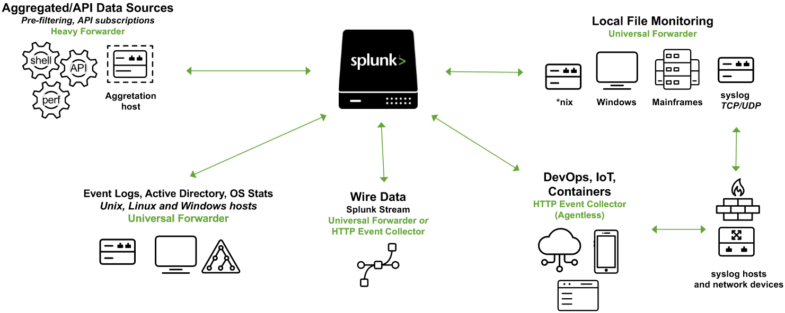
Splunk Architecture Overview:
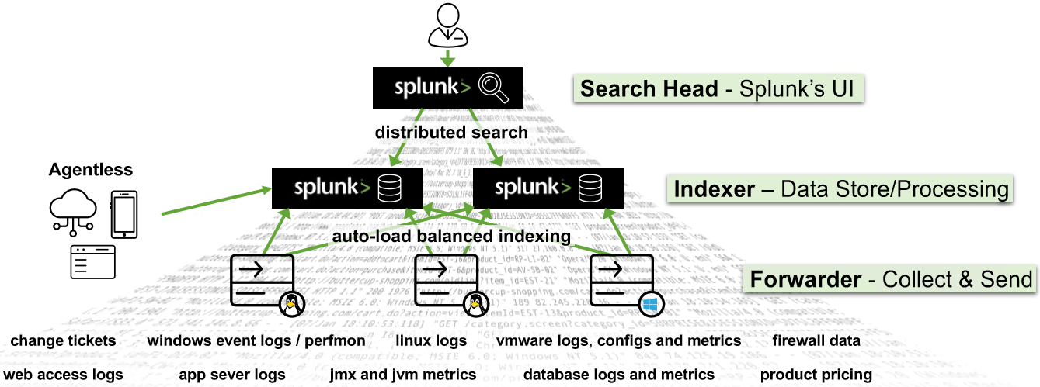
Splunk's architecture (at a high level) consists of the:
- Forwarder component
- Universal Forwarders collect data from remote sources and send them to one or more Splunk Indexers. Universal Forwarders are separate downloads that can be installed on any remote source, with little impact on network or host performance.
- Heavy Forwarders also collect data from remote sources, but they are typically used for heavy data aggregation tasks, from sources like firewalls or data routing/filtering passing points. According to Splunk, unlike other forwarder types, heavy forwarders parse data before forwarding them and can route data based on criteria such as source or type of event. They can also index data locally while forwarding the data to another indexer. Heavy Forwarders are usually run as "data collection nodes" for API/scripted data access, and they are only compatible with Splunk Enterprise.
Note: HTTP Event Collectors (HECs) also exist to collect data directly from applications, at-scale, through a token-based JSON or raw API way. Data are sent directly to the Indexer level.
- Indexer Component The Indexer processes machine data, storing the results in indexes as events, enabling fast search and analysis. As the indexer indexes data, it creates a number of files organized in sets of directories by age. Each directory contains raw data (compressed) and indexes (points to the raw data).
- Search Head Component The Search Head component allows users to use the Search language to search for indexed data. It distributes user search requests to the Indexers and consolidates the results as well as extracts field value pairs from the events to the user. Knowledge Objects on the Search Heads can be created to extract additional fields and transform the data without changing the underlying index data. It should be noted that Search Heads also provide tools to enhance the search experience such as reports, dashboards, and visualizations.
Splunk Apps and Technology Add-ons (TAs):
Splunk Apps are designed to address a wide variety of use cases and to extend the power of Splunk. Essentially, they are collections of files containing data inputs, UI elements, and/or knowledge objects. Splunk Apps also allow multiple workspaces for different use cases/user roles to co-exist on a single Splunk instance. Ready-made apps are available on Splunkbase (splunkbase.com).
Splunk Technology Add-ons abstract the collection methodology and they typically include relevant field extractions (schema-on-the-fly). They also include relevant config files (props/transforms) and ancillary scripts binaries.
You can think of a Splunk App as a complete solution, that typically uses one or more Technology Add-ons.
Splunk Users and Roles:
Splunk users are assigned roles which determine their capabilities and data access. Out of the box, there are three main roles:
- admin: This role has the most capabilities assigned to it.
- power: This role can edit all shared objects (saved searches, etc.) and alerts, tag events, and other similar tasks.
- user: This role can create and edit its own saved searches, run searches, edit its own preferences, create and edit event types, and other similar tasks.
Splunk's Search & Reporting App:
You will spend most of your time inside Splunk's Search & Reporting App.
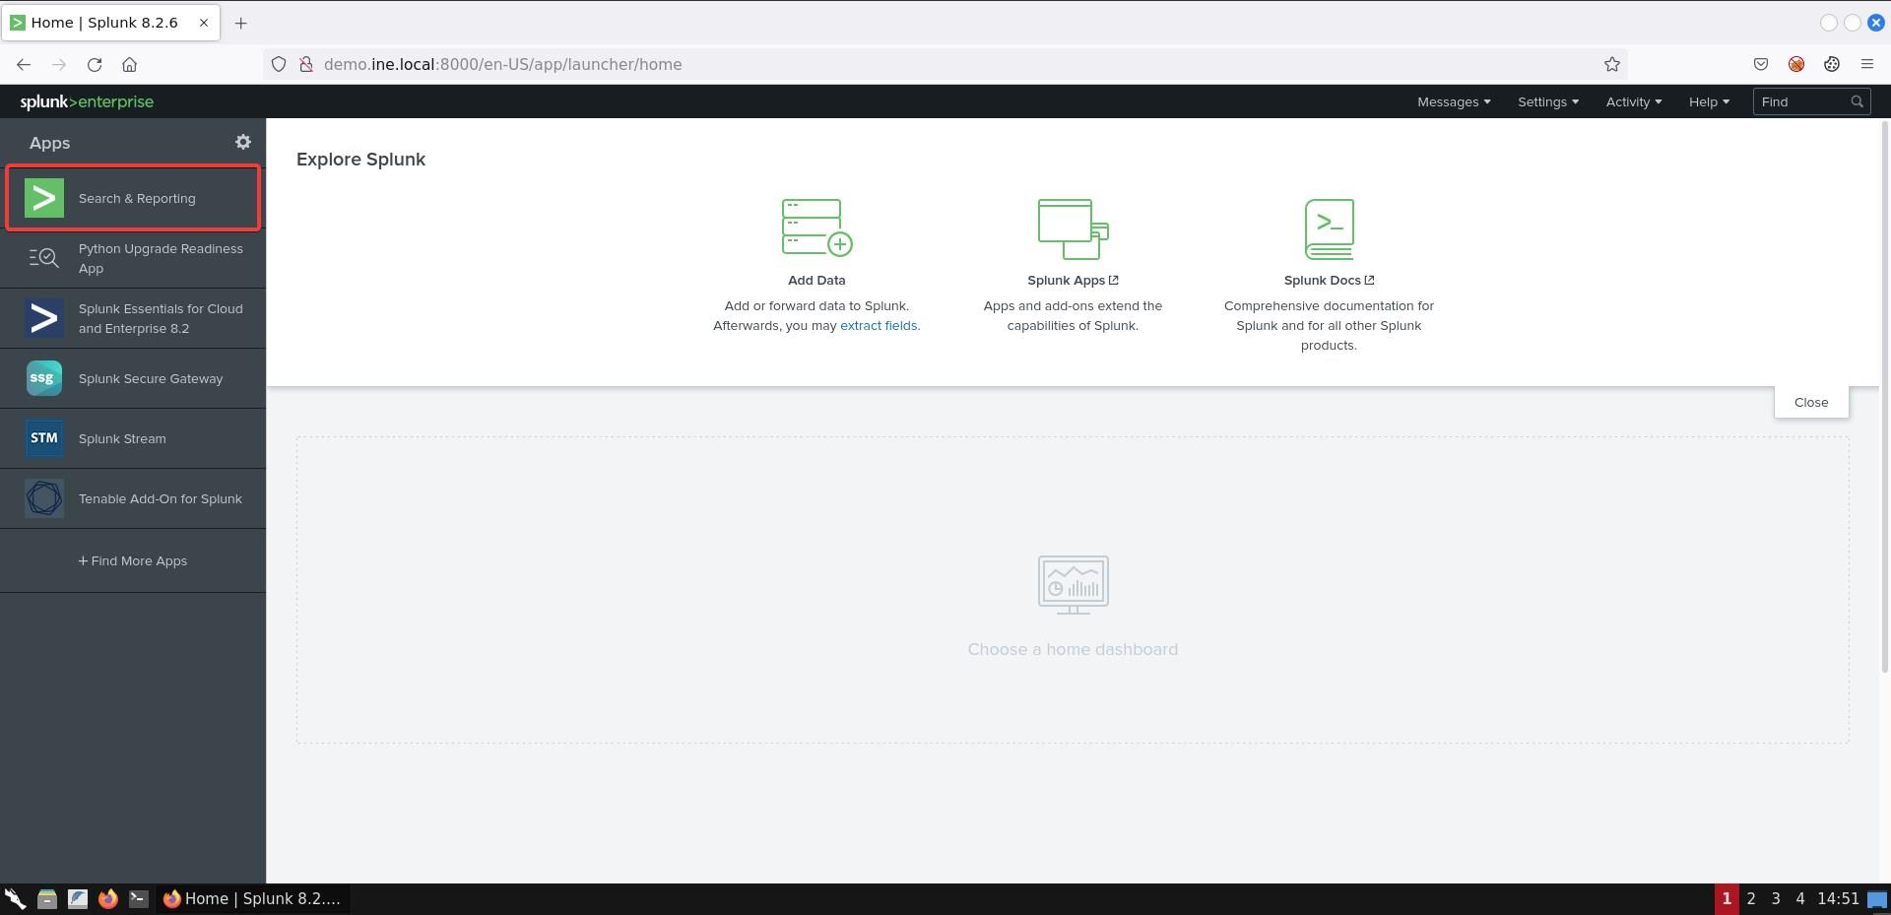
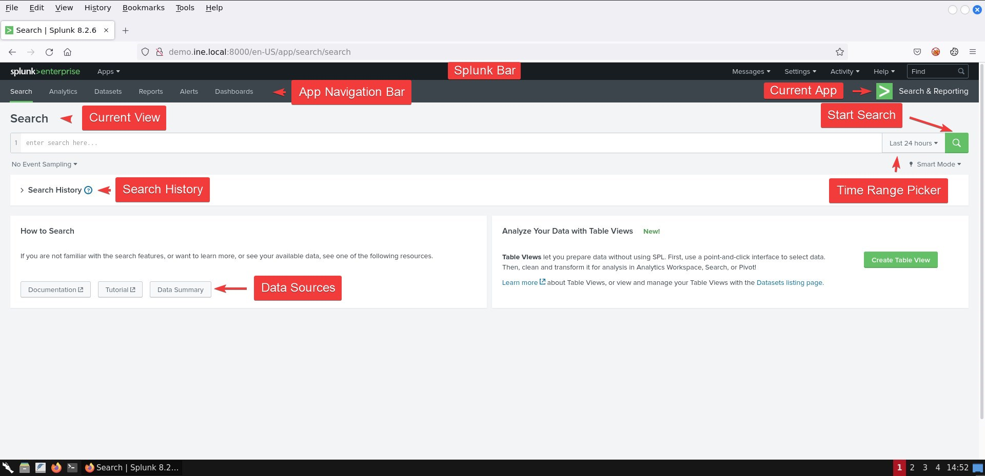
Data Summary can provide you with hosts, sources or sourcetypes on separate tabs.
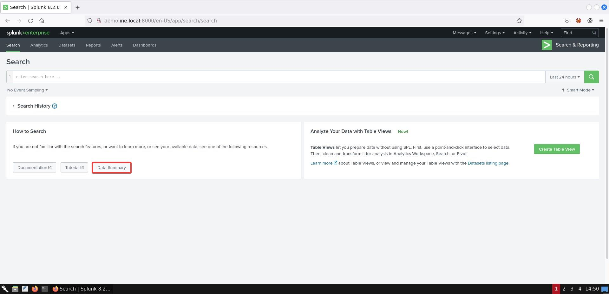
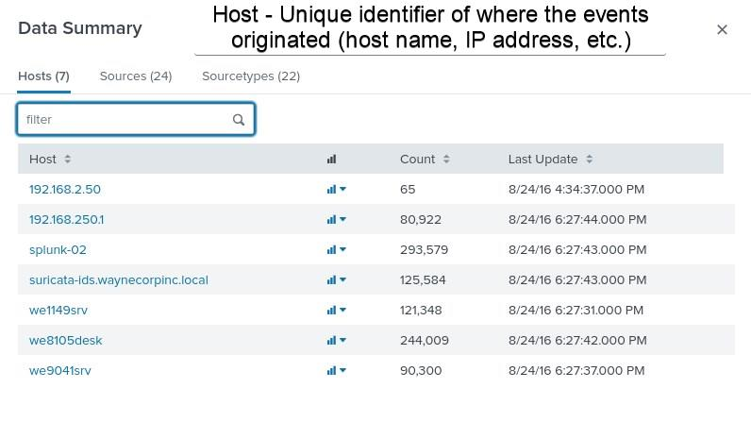
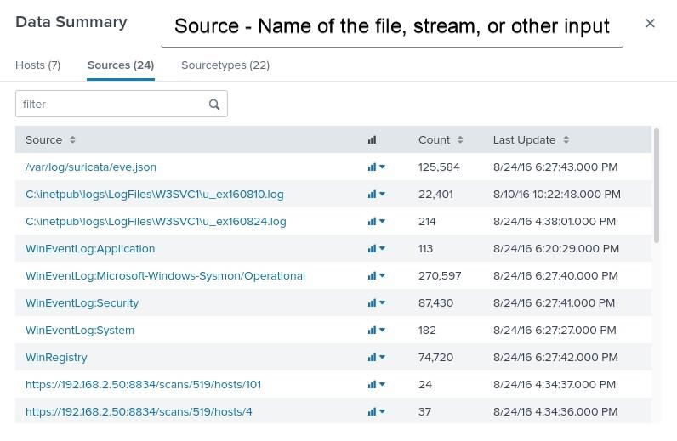
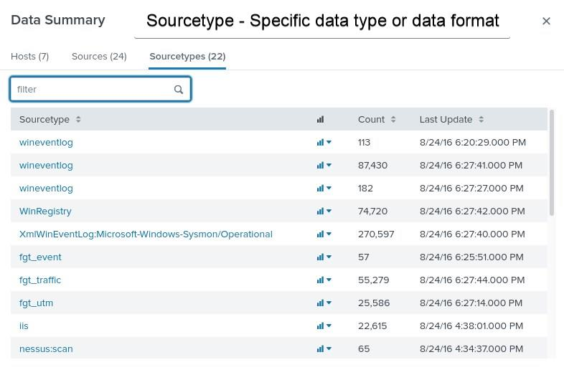
Finally, this is how Events will look like.
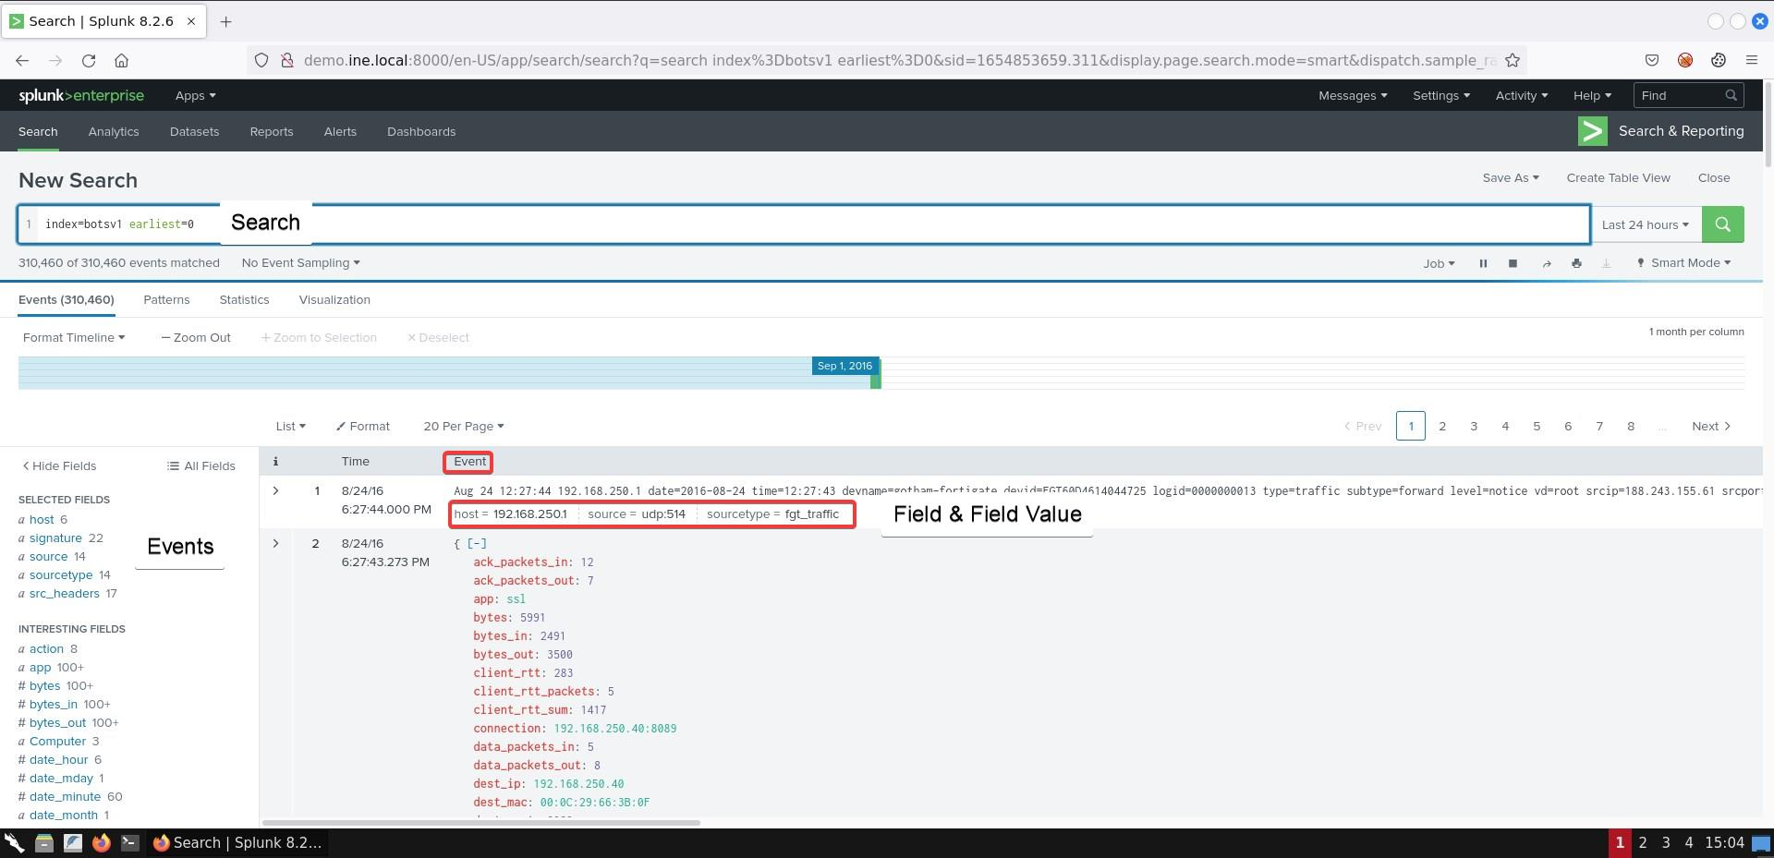
Splunk's Search Processing Language (SPL):
According to Splunk, SPL combines the best capabilities of SQL with the Unix pipeline syntax allowing you to:
- Access all data in its original format
- Optimize for time-series events
- Use the same language for visualizations
SPL provides over 140 commands that allow you to search, correlate, analyze and visualize any data.
The below diagram represents a search, broken down to its syntax components.
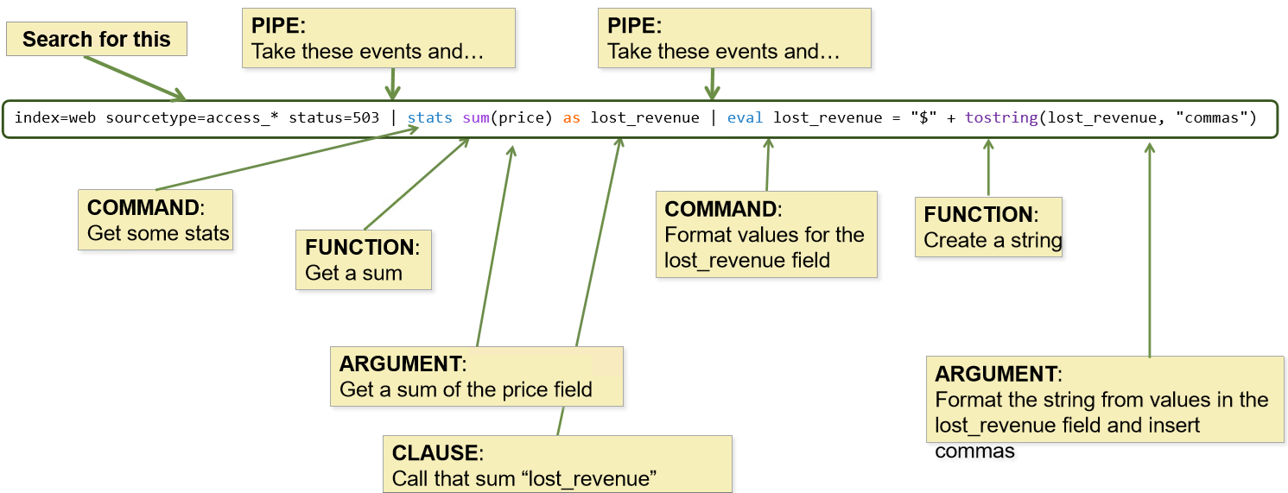
Searches are made up of five basic components.
- Search terms, where you specify what you are looking for. Search terms contain keywords, phrases, Booleans, etc.
- Commands, where you specify how you want to manipulate the results. For example, create a chart, compute statistics, etc.
- Functions, where you specify how exactly do you want to chart, compute or evaluate the results.
- Arguments, in case there are variables you want to apply to a function.
- Clauses, where you specify how exactly do you want to group or rename the fields in the results.
As you write searches, you will notice that some parts of the search string are automatically colored. The color is based on the search syntax. Example:
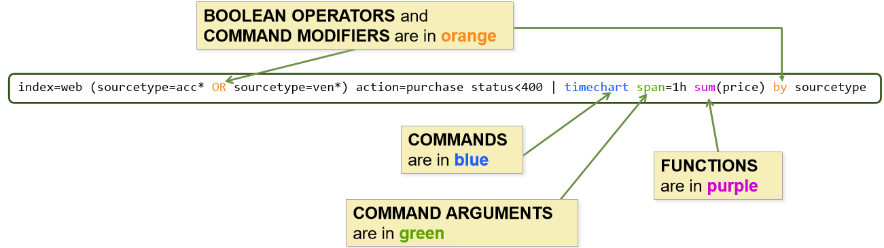
Something else to consider while submitting searches is Splunk's search modes.
There are three search modes:
- Fast Mode: Field discovery off for event searches. No event or field data for stats searches.
- Smart Mode: Field discovery on for event searches. No event or field data for stats searches.
- Verbose Mode: All event & field data.
It is recommended to start searching with Smart and then go from there.
We strongly suggest you spend time studying the Exploring Splunk (https://www.splunk.com/goto/book) e-book before proceeding to the lab's tasks. Especially Chapter 4, as that covers the most commonly used search commands.
Various Search aspects are also nicely documented, in the following resource in th Splunk Search Manual

Recommended tools
- Splunk

Network Configuration & Credentials

Recommended tools
- Splunk
- Use an internet browser to connect to Splunk's web interface (http://demo.ine.local:8000)

\

Tasks

Task 1. A password brute-forcing attempt took place against 192.168.250.70. what was the average password length used in the attack?
To identify the password brute-forcing attack utilize the stream:http sourcetype. Authentication takes place via POST (form_data field of the sourcetype) with parameters username (for the username) and passwd (for the password).

Task 2. Visualize the frequency of the password brute-forcing attack.
Visualize the frequency of the password brute-forcing attack.
Hint: The timechart command will prove useful for this task.

Task 3. How many seconds elapsed between the time we first saw the password "batman" and the time we saw it again?
Construct a Splunk search that can automatically determine how many seconds elapsed between the time we first saw the password batman and the time we saw it again.
Hint: The search and transaction command will prove useful for this task.

Task 4. Extend IP location to visualizations
Leverage the iplocation* and geostats commands for a bird's eye view of the IP addresses involved.
- Splunk ships with a copy of GeoLite2-City.mmdb from Maxmind. The iplocation command will enhance an event IP address with City, State, Country, Latitude and Longitude

Task 5. List all process execution activity and all executed commands
Leverage the available sysmon logs and construct two Splunk searches. One that will list all process execution activity and one that will list all executed commands.
Hint: The ParentImage and CommandLine fields will prove useful in this task.

SOLUTIONS
Kali Machine

From a web browser access the splunk console at http://demo.ine.local:8000.
Below, you can find solutions for each task. Remember though, that you can follow your own strategy, which may be different from the one explained in the following lab.

Task 1. A password brute-forcing attempt took place against 192.168.250.70. what was the average password length used in the attack?
Once you are logged into Splunk's web management interface, click the Search & Reporting application that resides on the Apps column on your left. You should see something similar to the below.
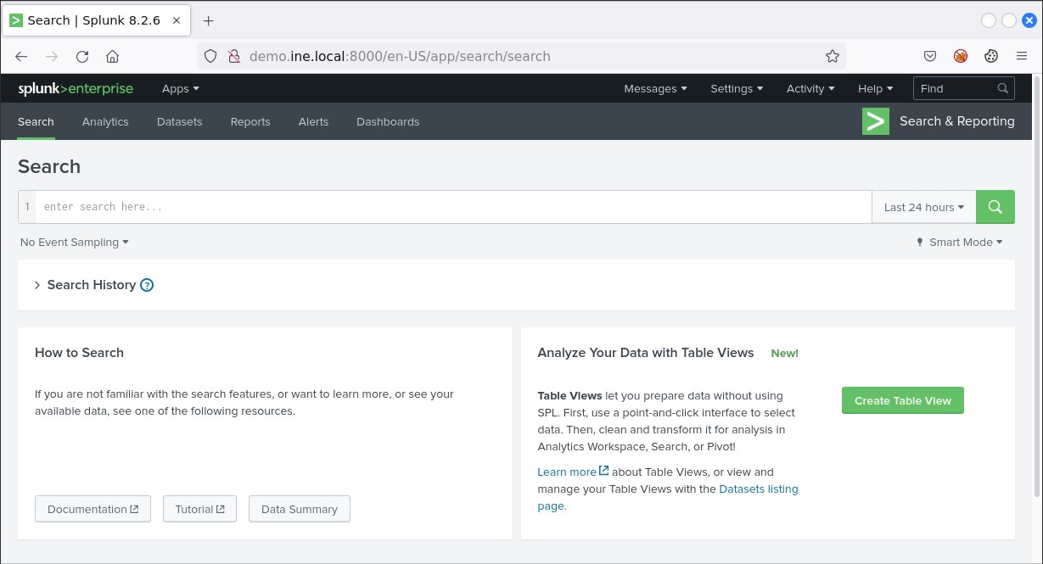
In order to test if Splunk can successfully access the ingested/loaded data, first change the time range picker to All time and then, submit the following search.
index="botsv1" earliest=0
You should see the number of events growing as time progresses.
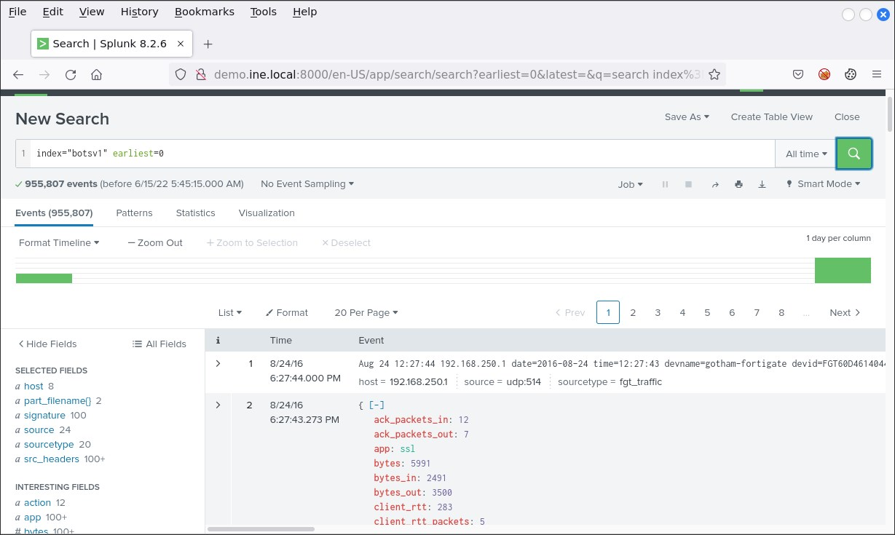
The first thing we should do is determine the available sourcetypes. Specifically, we should first determine the sourcetypes that are associated with 192.168.250.70. We can do so by changing the time range picker to All time and submitting the following Splunk search.
index=botsv1 192.168.250.70
You should see something similar to the below.
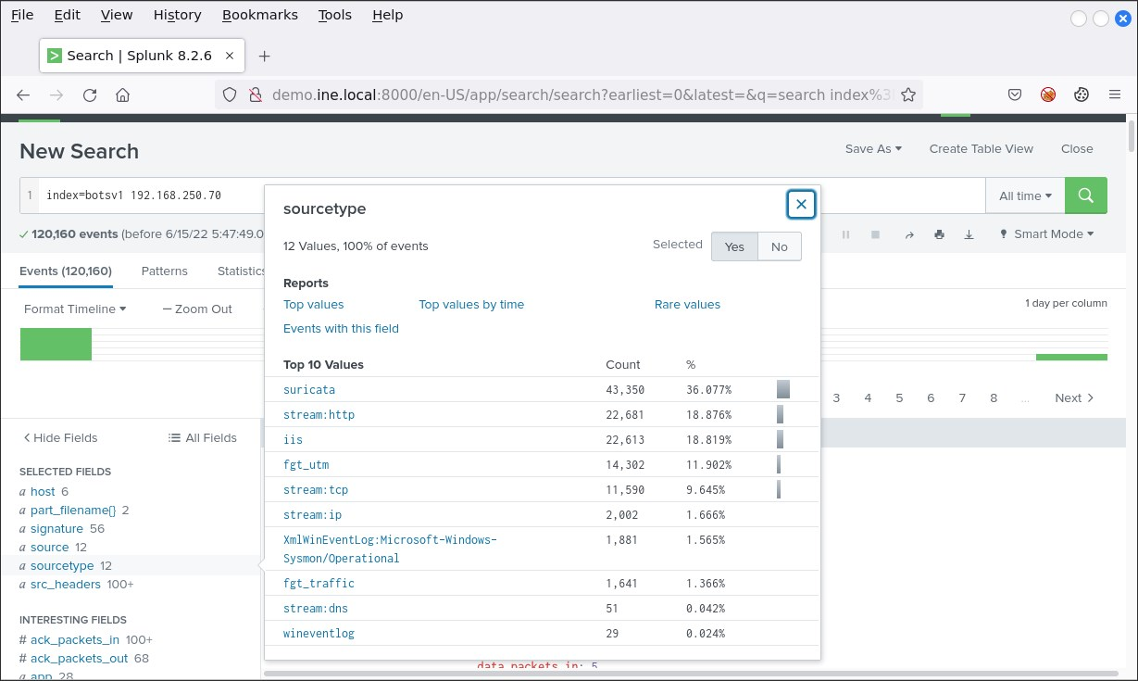
Now, to identify the password brute-forcing attack, we can use the below query.
index="botsv1" sourcetype="stream:http" dest_ip=192.168.250.70 http_method=POST form_data=*user*pass* | stats count by src_ip
Once the query is executed, we get the following result:
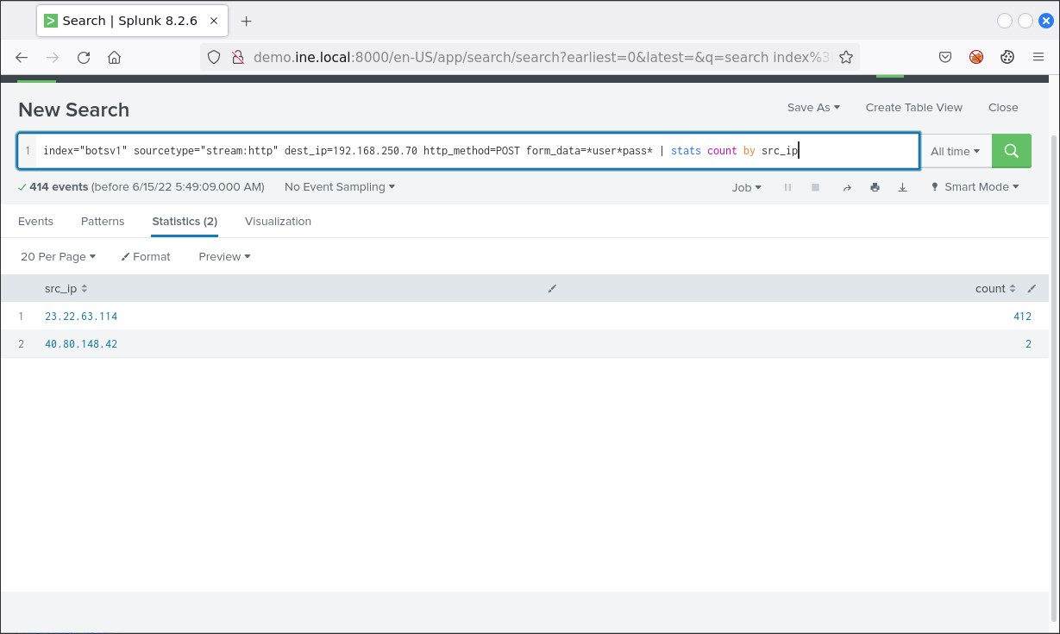
If you are wondering, how can we know these dest, http_method and form_data fields, you can identify them by clicking on the position indicated below (that will show you all the available fields of the sourcetype. Do this by modifying your query to only include index, sourcetype, and dest_ip
'''' index="botsv1" sourcetype="stream:http" dest_ip=192.168.250.70 ''''
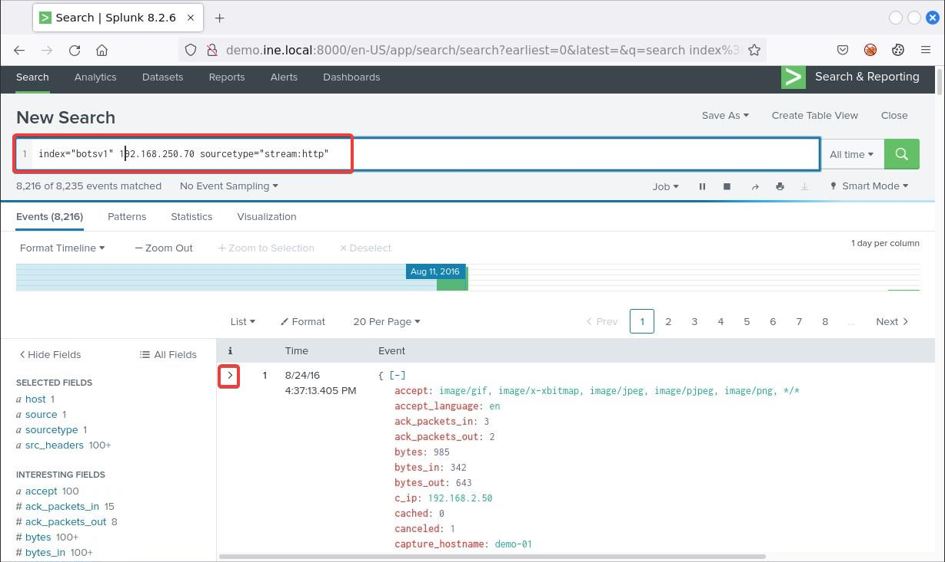
Finally, to identify what was the average password length used in the attack, we can use the below (more complex query).
index="botsv1" sourcetype="stream:http" dest_ip=192.168.250.70 http_method=POST form_data=*user*pass* | rex field=form_data "passwd=(?<userpassword>\w+)" | eval lenpword=len(userpassword) | stats avg(lenpword) AS avgPword | eval avgPword=round(avgPword,0)
Calculate a length for the userpassword string eval lenpword=len(userpassword)* <- Calculate a length for the userpassword string and store the value in lenpword
stats avg(lenpword) AS avgPword <- Calculate the average of all lenpword and rename it avgPword
eval avgPword=round(avgPword,0) <- Round the avgPword field to 0 decimal places and put it into the avgPword field
Once the query is executed, we get the following result:
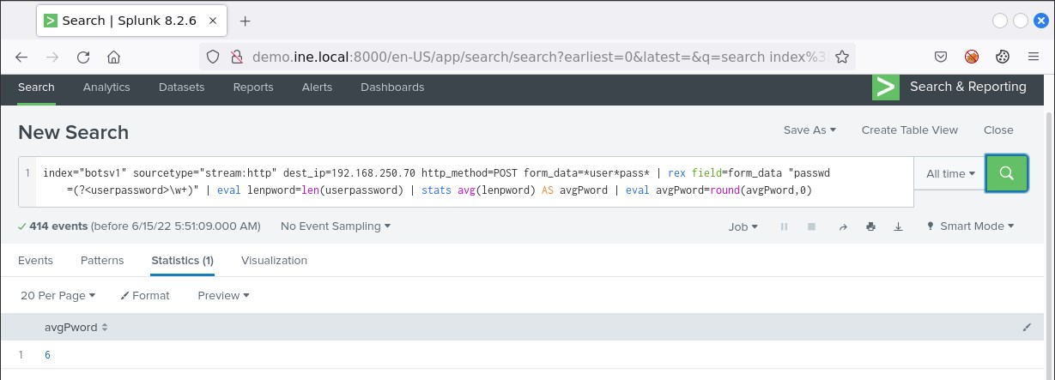
Now that we know the attackers password length is set to 6 we can visualize our analysis

Task 2. Visualize the frequency of the password brute-forcing attack.
To visualize the frequency of the password brute-forcing attack, we can use the query below.
index="botsv1" sourcetype="stream:http" dest_ip=192.168.250.70 http_method=POST form_data=*user*pass* | rex field=form_data "passwd=(?<userpassword>\w+)" | timechart span=1s count by dest_ip
This is a similiar query as too our final Task 1 query, note that we removed the eval and stats sections and added a timechart
timechart syntax is similar to stats
Once the query is executed, we get the following result:
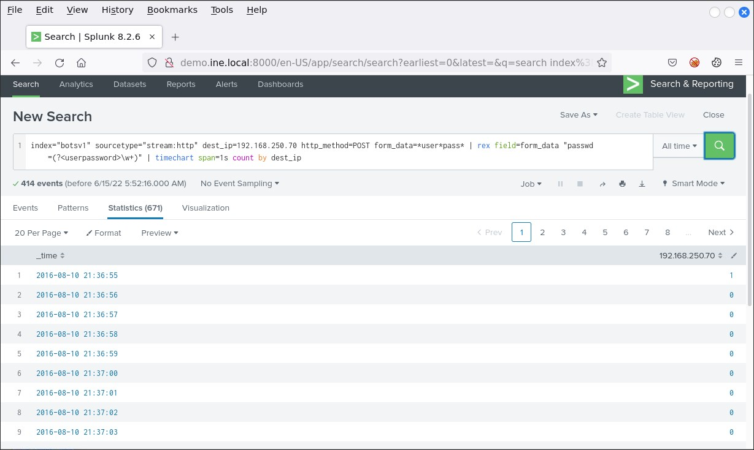
We also receive a visualization by clicking on Visualization
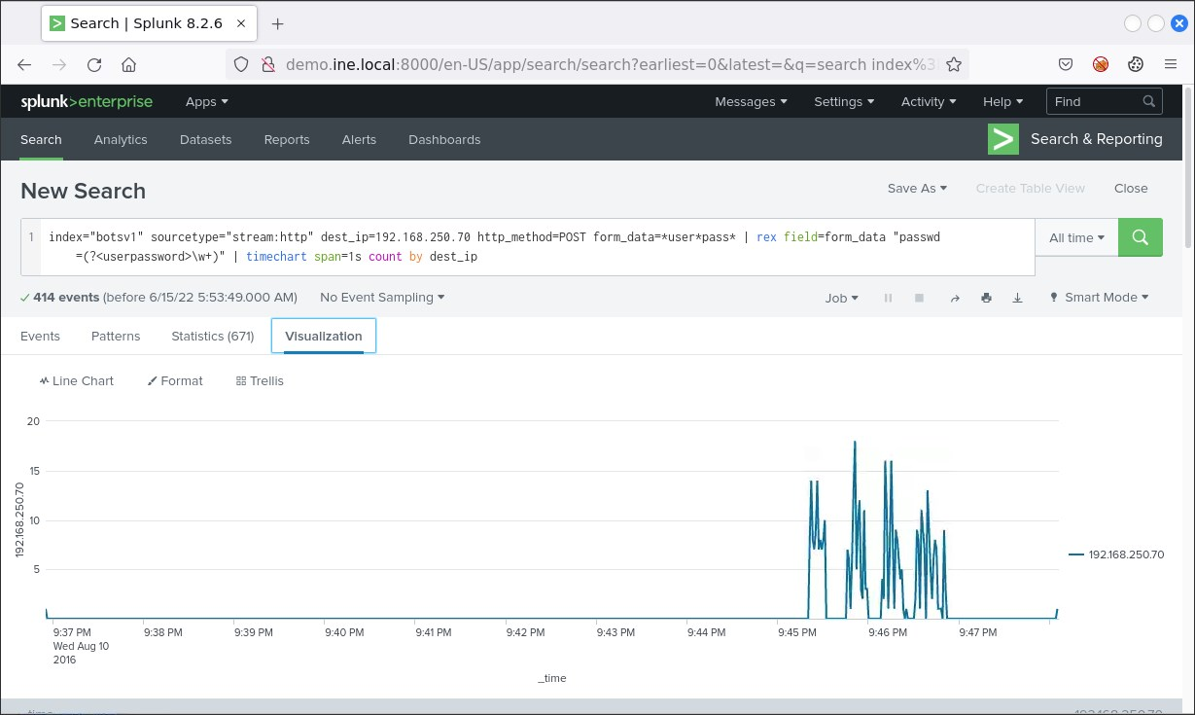
With our visualization we now know the time ranges of the attack.

Task 3. How many seconds elapsed between the time we first saw the password "batman" and the time we saw it again?
A splunk search that can automatically determine how many seconds elapsed between the time we first saw the password batman and the time we saw it again can be found below.
index="botsv1" sourcetype="stream:http" dest_ip=192.168.250.70 http_method=POST form_data=*user*pass* | rex field=form_data "passwd=(?<userpassword>\w+)" | search userpassword=batman | transaction userpassword | table duration
Change the Visualization from Line Chart to Cluster Map
Once the query is executed, we get the following result:
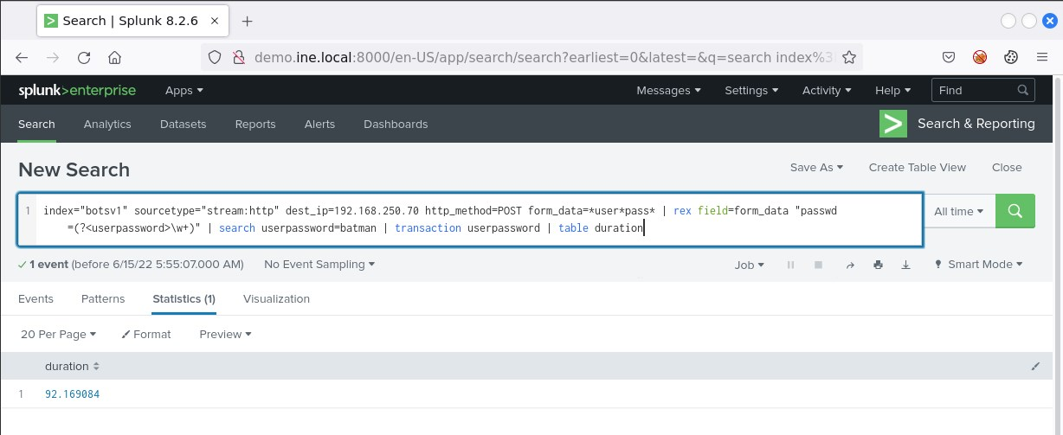

Task 4. Extend IP location to visualizations
The below Splunk search can provide us with a bird's eye view of the involved IP addesses.
index="botsv1" sourcetype="stream:http" dest_ip=192.168.250.70 http_method=POST form_data=*user*pass* | iplocation src_ip | geostats latfield=lat longfield=lon count by src_ip
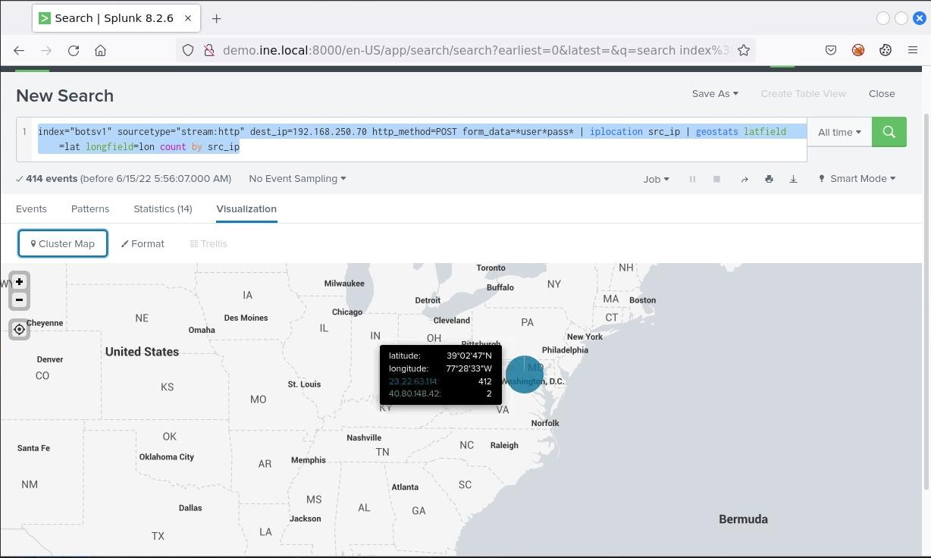

Task 5. List all process execution activity and all executed commands
All process execution activity can be listed through the Splunk search below.
index="botsv1" sourcetype="xmlwineventlog:microsoft-windows-sysmon/operational" | stats values(ParentImage) by process
Once the query is completed, we get the following result:
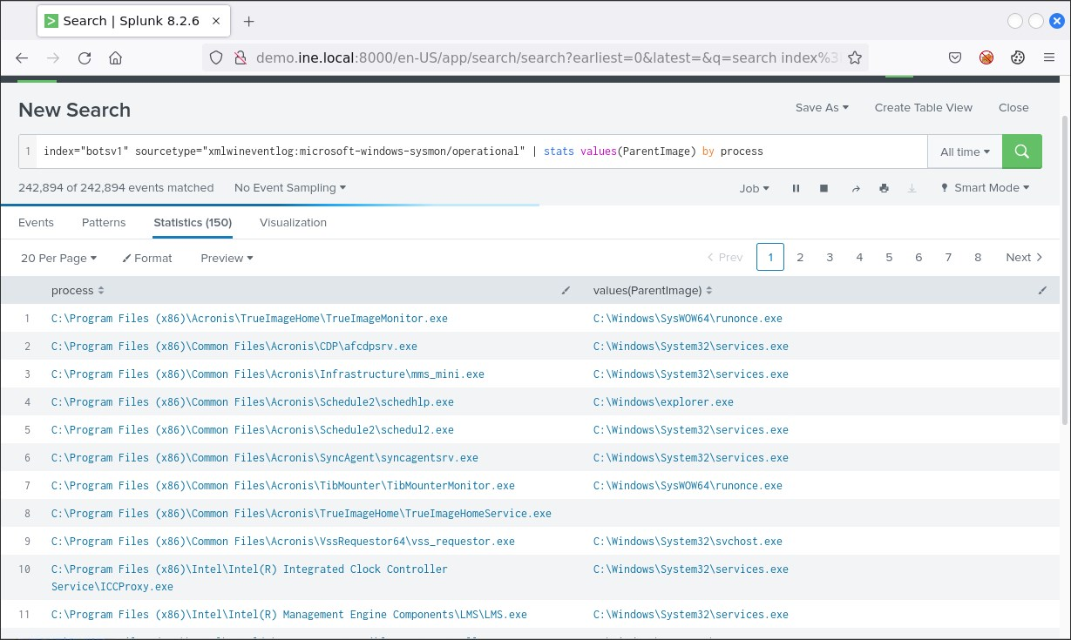
All commands being executed can be listed through the Splunk search below.
index="botsv1" sourcetype="xmlwineventlog:microsoft-windows-sysmon/operational" | stats values(CommandLine) by Computer,process
Once the query is completed, we get the following result:
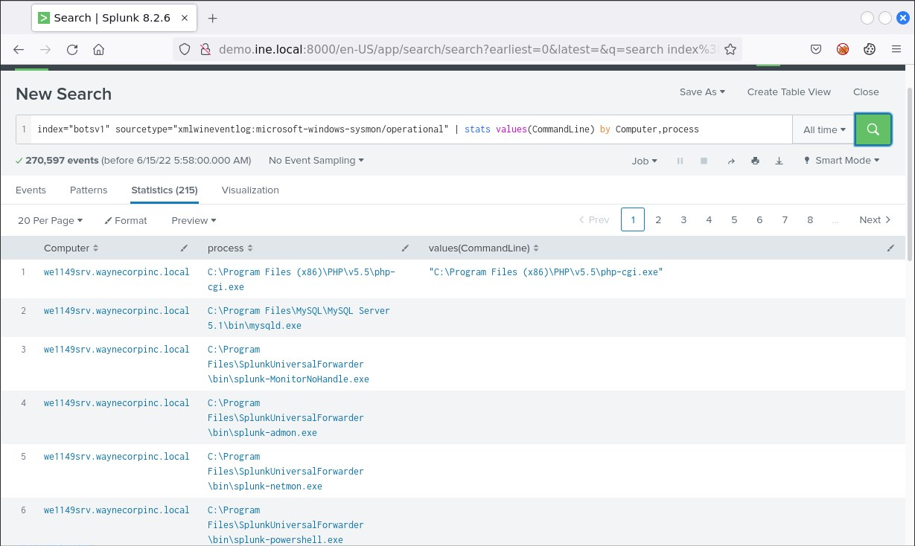
Bonus 1: If you want to list all commands being executed by a specific (usually abused) process, you can do so as follows.
index="botsv1" sourcetype="xmlwineventlog:microsoft-windows-sysmon/operational" process=*cmd.exe | stats values(CommandLine) by Computer,process
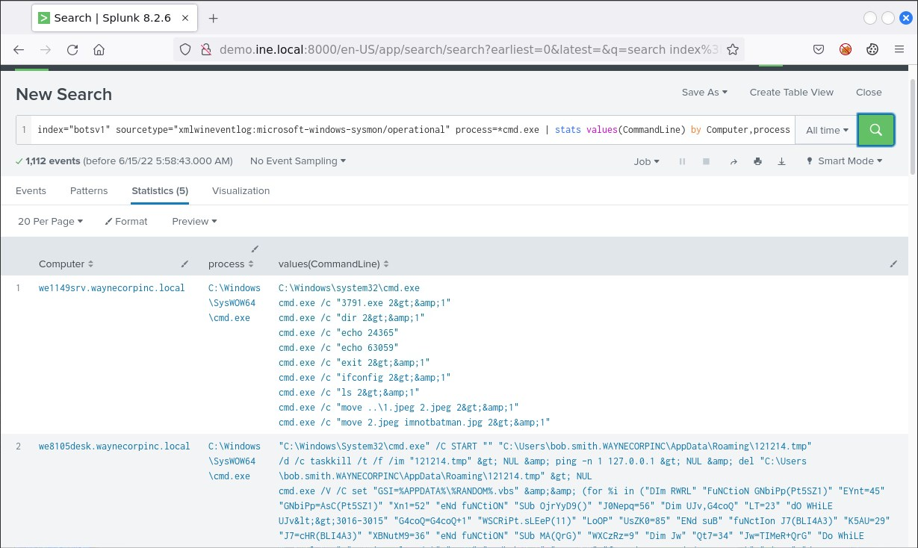
Bonus 2: If you want to identify, for example, the longest cmd.exe command that was executed (overly long commands are suspicious), you can do so as follows.
index="botsv1" sourcetype="xmlwineventlog:microsoft-windows-sysmon/operational" process=*cmd.exe | eval len=len(CommandLine) | table User, len, CommandLine | sort -len
Once the query is completed, we get the following result:
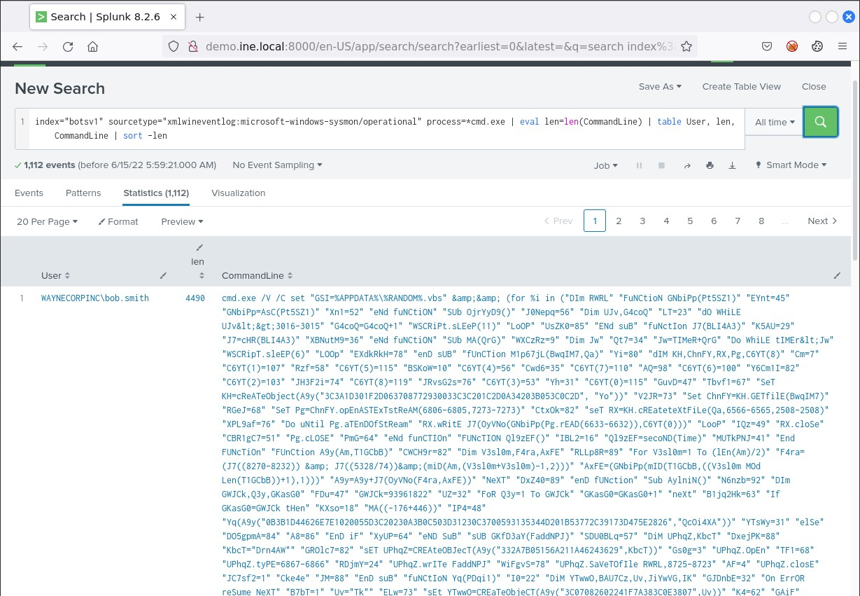
That overly-long cmd.exe command looks certainly malicious!

